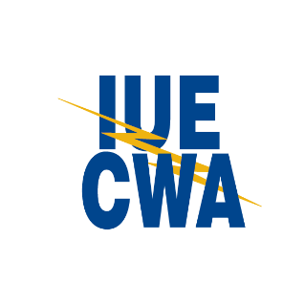
New Member Sign Up Cards – Copies for IUE Headquarters
1. Please send copies of all new member sign up cards to IUE Headquarters as soon as you get them. In addition, if you have any COPE/Political Action Fund sign up cards, send those as well.
2. You must keep the original copy of your new member cards on file at your Local in a secure, fire-proof location.
3. Provide a copy of the new member cards/COPE Sign Ups to your employer, so they begin taking deductions.
4. Please fill out and include this form with your copies when you send them to HQ.
Local Number: __________________________________________________
Name of person sending the copies of cards: _________________________________

Contact phone number if we have questions about the cards: __________________________
_____ Check here if you would like to request new member kits be sent to your local for new hire orientation.

If so, how many kits are you requesting? _________________
Local Address if requesting new member kits: (Address cannot be a PO Box to receive new member kits)

______________________________________________________________________________________
Street City State Zip
5. Send the copies of new member cards via one of the following:
Fax: 937-298-2636, Attn: Kim Short
Email: Kshort@iue-cwa.org
Mail:
IUE-CWA Headquarters
Attn: Kim Short
2701 Dryden Road
Dayton, OH 45439

Questions? Call Kim Short at (937)298-9984.

